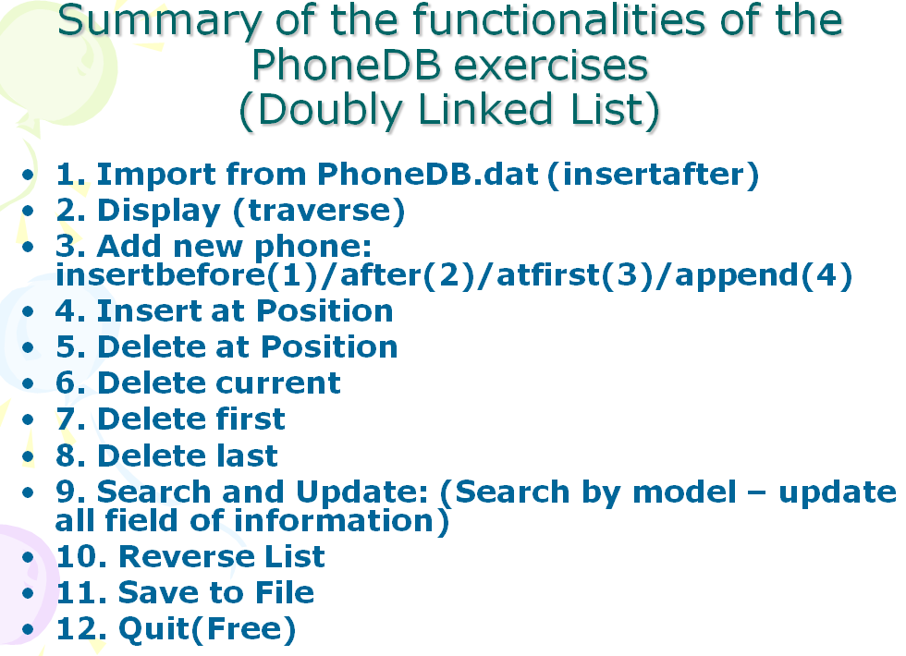

**NOTICE: You have to implement the generic library for doubly linked list and use it for this homework. Student is encouraged to implement the version that work with many list at the same time.**

